***555 Timer Calculations***

Basic 555 timer structure,

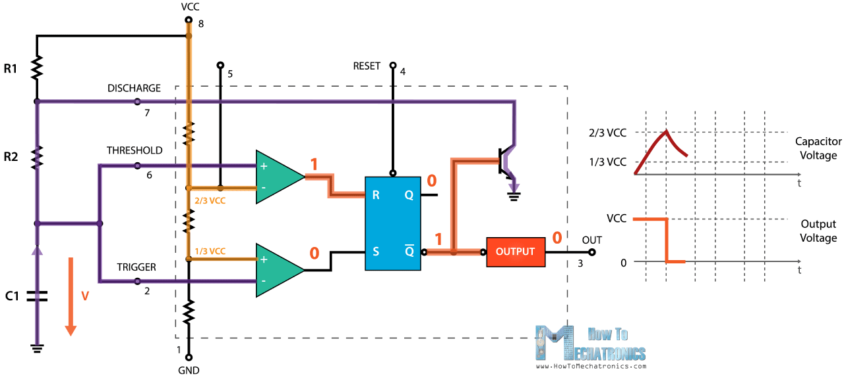

Formulas,

$$T_{on}=0.693*(R_{1}+R_{2})*C_{1}$$

$$T_{of}=0.693*R_{2}*C_{1}$$

$$T_{total}=0.693*{(R}_{1}+2R_{2})*C_{1}$$

$$f=1/(0.693*{(R}_{1}+2R_{2})*C_{1})$$

$$PWM\left(\%\right)=\frac{T_{on}}{T_{total}}=\frac{(R_{1}+R_{2})}{{(R}_{1}+2R_{2})}*100$$

In order to create adjustable PWM, we add this configuration to the diodes and POTs via the charging and discharging paths.

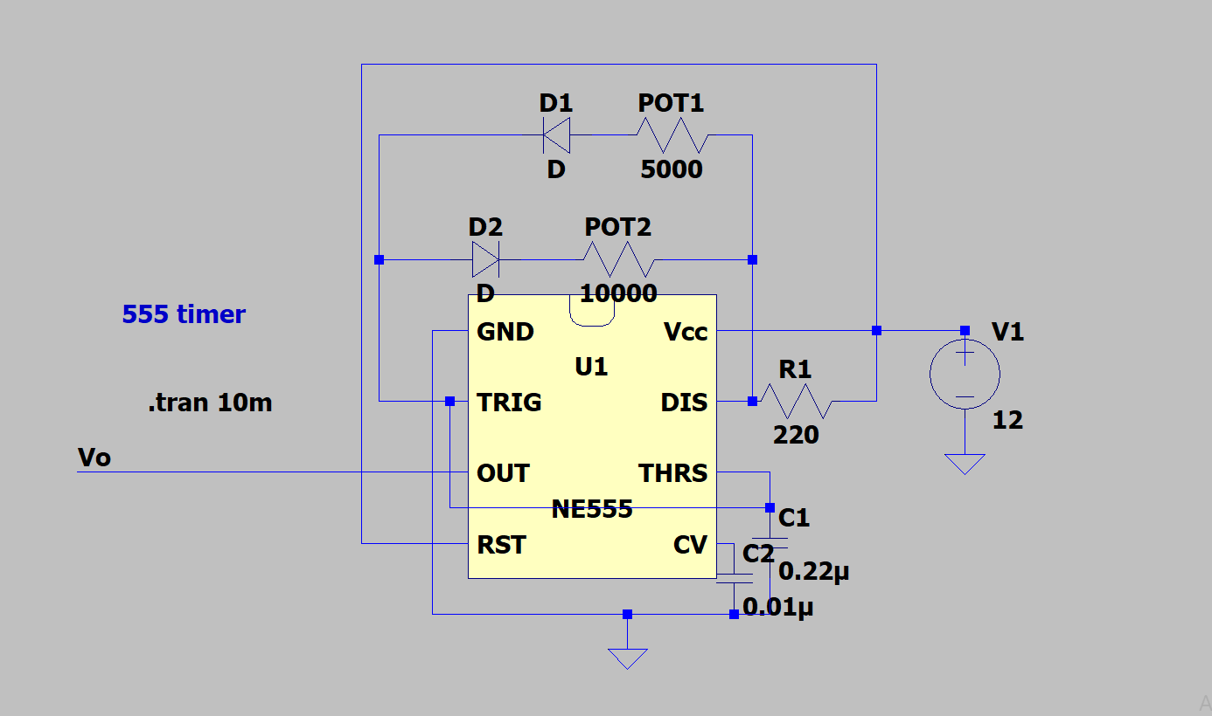

Calculations,

$$T_{on}=0.693*{(R}_{POT1}+R_{1})*C_{1}$$

$$T_{of}=0.693*{(R}_{POT2}+R_{1})*C_{1}$$

$$T_{total}=0.693*{(R}_{POT1}+R_{POT2}+{2R}_{1})*C_{1}$$

$$f=1/(0.693*{(R}_{POT1}+R_{POT2}+2R_{1})*C_{1})$$

$$PWM\left(\%\right)=\frac{T_{on}}{T_{total}}=\frac{R_{POT1}+R_{1}}{R_{POT1}+R_{POT2}+2R_{1}}*100$$

We have used 5kΩ and 10kΩ resistance respectively for POT1 and POT2. In real, POT1 is changing between 1.6Ω and 4.8k Ω and POT2 is changing between 2.8Ω and 9.6kΩ. Then,

PWM maximum,

$$T_{on}=0.693*\left(4.8kΩ+220Ω\right)*0.22*{10}^{-6}=0.795ms$$

$$T_{of}=0.693*\left(2.8+220Ω\right)*0.22*{10}^{-6}=0.034ms$$

$$f=1.19kHz$$

$PWM\left(\%\right)=$ 98%

PWM minimum,

$$T_{on}=0.693*\left(1.6Ω+220Ω\right)*0.22*{10}^{-6}=0.0337ms$$

$$T_{of}=0.693*\left(4.8k+220Ω\right)*0.22*{10}^{-6}=1.558ms$$

$$f=628Hz$$

$PWM\left(\%\right)=$ 2.1%

Although we could reach these PWM values, we have to stay away from the boundary points of PWM. This is because at the near of 0% and 100% PWM values, switch (IGBT) cannot be operated properly since it has switching time interval of ON and OFF times, PWM is not enough to compensate it. Therefore, we changed R1 with 1kΩ and we have adjusted PWM between 17% and 85%. By the same steps,

PWM maximum,

$$T_{on}=0.884ms$$

$$T_{on}=0.152ms$$

$$f=965Hz$$

$PWM\left(\%\right)=$ 85%

PWM minimum,

$$T_{on}=0.152ms$$

$$T_{on}=0.884ms$$

$$f=965Hz$$

$PWM\left(\%\right)=$ 17%

As seen from obtained results, the operating frequency is around 1kHz, so we decide to use IGBT as a switch. The performance of IGBT is greater than MOSFETs and other switches at low frequencies. Also, the current rating of IGBTs can reach up to 1kA.